IMO Bulletin

December 2017
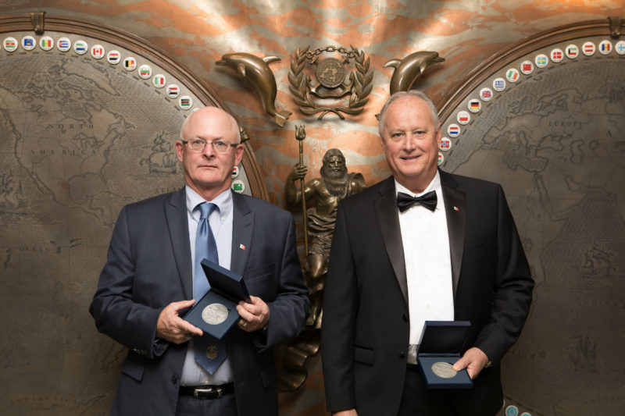
The IMO Award for Exceptional Bravery at Sea
Two Houston Ship Pilots Captain Michael G McGee and Captain Michael C Phillips, Have received the Exceptional Bravery Award risking their lives to bring a burning ship to safety.
The pilots, members of the Master Mates and Pilots, were presented with the highest honor for bravery at sea at a ceremony at the IMO headquarters.
IMO Assembly. 30th Session
The IMO Assembly is the highest body of the organisation which meets two yearly to sanction the work of the committees, agree the budget, acknowledge the strategic direction and plan and elect the council to manage its operation for the following two years. At the 30th session the ten category A members elected were, China, Japan, Italy, Panama, Greece, Rep of Korea, Russia, UK, Norway, US. Ten more were elected in category B and twenty in category C. Whilst ,as observers, the NGOs have no role in the election it is important for us to have Council members that empathy for the seafarers.
Prior to the election for council the majority of flag states made statements generally supporting the IMOs work for a safe, secure and clean sea but also identifying their specific concerns. The majority supported the program to reduce greenhouse gases but small island states called for urgency in the work of the IMO. New Zealand and Canada, amongst others, spoke of the need for the Polar code to be extended to non SOLAS vessels and the continued loss of fishing vessels. A substantial number spoke on the urgent need for the IMO to address the autonomous ship. Finland stated that the IMO was 10 years behind in technology and there was need for an accelerated process. Japan spoke of removing obstacles to total automation and the removal of the human error. The US however stated autonomous ships are not the future, but already a fact of life, and although they support the scoping of regulations to facilitate the autonomous ship, stated it required the right balanced approach to legislation and enforcement. It was disappointing though that only three speakers expressed any concerns and considerations for the seafarer. France strongly emphasised that the role of seafarers was crucial to the industry and they deserved careful attention. Both Italy and the Philippines spoke of the essential contribution and importance of seafarers. The Secretary General in his report on the Day of the Seafarer also spoke of the crucial role of seafarers and recognised the prime role of the IMO regulations was for the protection of seafarers. This could be of major importance in the coming debate on autonomous ships.
The only other substantial issue raised by a flag was the need to address administration burden for seafarers tabled by Russia. The Philippines submitted that suitable manning should be considered to cover the high level of paperwork and Malta called for input from the ITF and others as how this can be addressed. The issue has been forwarded to the council which has previously considered this matter although not with an emphasis on seafarers.
COUNCIL UPDATE
The chair of the Council has passed from the US to China but the vice chair will be decided later based on gender equality within the IMO.
The new Director of the Maritime Safety Division is Hieke Deggim and the Director of Maritime Environmental Division is
H Yamada
’

30th Assembly Resolutions include the following:-

- Escape route signs and equipment location markings
- IMO Ship Identification Number Scheme
- Revised guidelines on implementation of the ISM Code by Administrations.
- Procedure for Port State Control 2017
- Survey Guidelines under the HSSC 2017
- 2017 Non-exhaustive list of obligations under instruments relevant to the III Code.
- Strategic Plan for the organisation for the six-year period 2018 to 2023.

The 2nd Meeting of the Intersessional Working Group on Reduction of GHG Emissions

This meeting endeavoured to make progress on the IMO strategy on reduction of GHG emissions from ships. Unfortunately much of the content and in particular the implementation dates are not agreed and most of the options are in square brackets. The 14 page document continues to be aspirational and we made little progress in the last few meetings. There is no doubt that the majority of flag states accept and support the IMO goal of reducing greenhouse gas emissions from ships but the argument is, who pays? how quickly? and will it penalise global trade and growth?

As we have found in the EEDI (Engine Efficiency Design Index) debate, there is very advanced technology available which enables new tonnage to exceed the efficiency improvements agreed however in an industry where a ships life is around 25 years it still leaves a long term problem for older tonnage.

The strategy currently includes some of these options on the table but not agreed;
- Full decarbonisation by 2035 or
- Based on 2008,100% reduction by 2050 or
- Based on 2008, 50% reduction by 2060

Obviously there is a way to go and we will again address EEDI at the next MEPC . There are idealists that think we can just keep lowering the power and speed of ships or refit ships with new engines running on cleaner fuels. There is still discussion on Market Base Measures or a carbon tax but this is very contentious particularly with developing countries.
We will continue to participate in the Committee and working group as issues such as minimum manoeuvring power are a direct concern of members.

John Bainbridge …Nautilus Federation, IMO Consultant

